Study information

**Title**:

The Uncanny Valley Hypothesis: Examining the Moderating Role of Motion and Appearance. A Replication of Piwek, McKay and Pollick (2014).

**Authors**:

Sean Hughes

Ghent University

Department of Experimental Clinical and Health Psychology

Stephanie Timperman

Ghent University

**Description**:

The uncanny valley hypothesis refers to the idea that almost but not fully humanlike artificial characters will trigger a profound sense of unease in people. This hypothesis is widely claimed in the popular media and scientific research. Yet, despite its popularity, empirical evidence for this claim remains inconsistent. In this pre-registered replication effort, we set out to replicate the findings reported by Piwek et al. (2014).

Piwek et al. (2014) argued that improving the motion quality of characters systematically improved the perceived acceptability of those characters. Specifically, the character classified in the deepest location of the uncanny became more acceptable when it was animated. They claimed that although an uncanny valley effect emerged for static characters, the deepening of the valley with motion, originally predicted by Mori (1970/2012), did not produce a stronger effect.

**Confirmatory Hypotheses**:

**H1**: Ratings of human likeness (i.e., how similar to human a character is) will differ as a function of *Character Type*.

**H1a**. Follow-up comparison tests will examine if Piwek et al.’s (2014) findings replicate. Specifically, if the (battle and toy) robots will be rated lower in human likeness than a mannequin (while not differing from one another); that the mannequin will be rated lower in human likeness than a skeleton or zombie (again these two latter characters will not differ from one another); and the skeleton and zombie will be rated as lower in human likeness than the two human figures (low- and high-resolution man).

**H2**: Acceptability ratings will vary as a function of *Character Type.*

**H2a**. Follow-up comparison tests will examine if Piwek et al.’s findings replicate, such that characters close in likeness to humans but not themselves human (e.g., zombie, skeleton), will be accepted least, characters that are most (e.g., humans) and least like humans (e.g., robots) will be accepted relatively more.

**H3**: Acceptability ratings will vary as a function of *Motion Type.*

**H3a**. Follow-up comparison tests will examine if Piwek et al.’s findings replicate, such that the uncanny valley effect (see H2) will be larger for static characters than moving characters. Increasing movement distortion is predicted to lower acceptability ratings for all characters relative to those obtained for characters in the natural motion condition.

**H4**: There will be an interaction effect between *Character Type* and *Motion Type* for acceptability ratings.

**H4a**. Follow-up comparison tests will examine if Piwek et al.’s findings replicate. Specifically we will examine if degrading motion has a generally negative effect on all characters, with the change in acceptability ratings from static to naturally moving differing as a function of character. Naturally moving zombies are predicted to be significantly more acceptable than the static zombie.

Design plan

**Study Type:**

This is an experimental study and will be conducted online. Participants will be recruited via the Prolific website (<https://prolific.co/>).

**Blinding**:

Participants will be blind to the purpose of the study when taking part. However, they will be informed about the purpose of the study after completing it (i.e., during the debriefing phase).

**Study Design:**

The Piwek et al. (2014) study contained two outcome measures (human likeness ratings & acceptability ratings).

With respect to the human likeness ratings, participants will rate seven different characters (i.e., a battle robot, toy robot, mannequin, skeleton, zombie, low-resolution man, and high-resolution man) in terms of their likeness to humans (i.e., when it comes to human likeness ratings there will be a single factor [*Character Type*] with seven levels).

With respect to acceptability ratings, a 7(*Character Type*) x 6 (*Motion Type*: static vs. natural motion vs. distorted A, vs. distorted B vs. distorted C vs. distorted D) x 5 (*Levels of Movement*) within-participants design will be employed, such that participants will rate all character types across all levels and types of motion in terms of how acceptable those characters are.

**Randomization:**

Participants will be randomly assigned to either the human likeness or the acceptability condition. Presentation of the stimuli will be randomly counterbalanced in each condition.

Sampling Plan

**Existing Data:**

In our study, we will collect entirely new data. These data have not yet been collected, created, or realized.

**Explanation of Existing Data:**

Piwek et al. (2014) recruited forty students (M*age* = 25, *SD* = 4.7) from a Scottish university and paid them for their participation. They divided those participants into two experimental groups: human-likeness condition and acceptability condition.

**Data Collection Procedure:**

Participants will be recruited through an online data collection platform (Prolific) and provided with a monetary reward for their efforts (at a rate of £6 per hour).

**Sample Size:**

We are interested in achieving 90% power to detect 75% of the interaction effect reported in Piwek et al. (2014) (*Partial Eta Squared ƞ²p = 0.171 > 0.140*). We used a formula to transform Partial Eta Squared to Effect Size f= 0.45 (*f=√ ƞ²p/1- ƞ²p*). Given a 90% power, an error probability of 5%, and the original design, the sample size requires 60 participants.

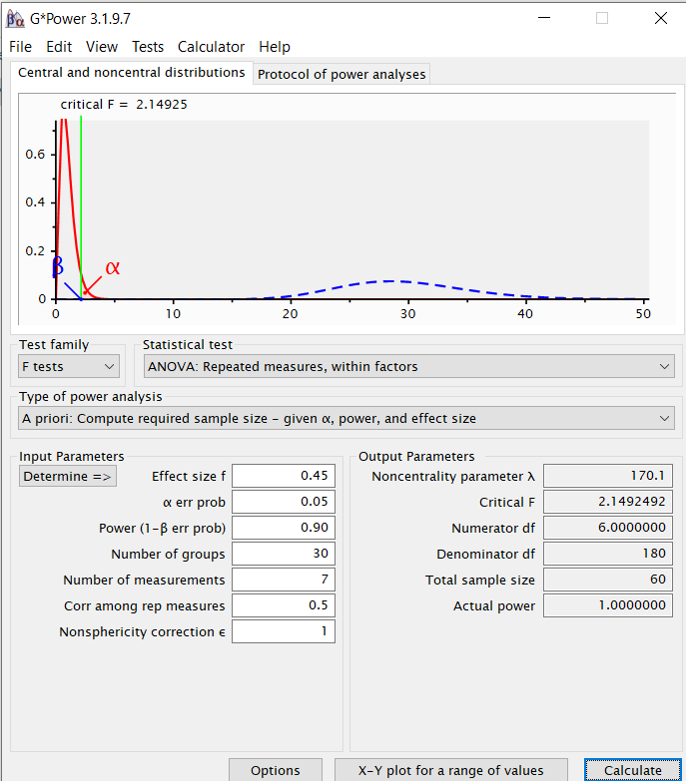

**Deviations from Original Study**

In the human likeness condition of Piwek et al. (2014) each participant completed 7 trials (one for each static character) and provided human likeness and acceptability ratings for each.

In the acceptability condition of Piwek et al. (2014) each participant completed 651 trials (i.e., 630 moving character trials [7 characters * 5 levels of movement * 6 variations of each level of movement = 210 trials * 3 repetitions] and 21 static character trials [7 characters * 3 repetitions]).

Based on our previous experience with the Prolific recruitment platform, we determined that this number of trials would likely elicit excessive levels of attrition. We therefore deviated from the original study by having each participant complete 231 moving character trials (i.e., 7 characters * 5 levels of movement * 6 variations of each level of movement) + 21 static character trials (7 static displays * 3 repetitions).

To compensate for the reduced number of trials we increased the required sample size (*n* = 60 to *n* = 300 in this replication study).

**Stopping Rule:**

Data collection will continue until we obtain complete and analysable data for 442 participants. In a first step, we will begin by collecting 472 participants (the required sample size plus an additional 30 participants to allow for attrition, incomplete, or unanalysable data). If at this point the required sample size is not met, then data collection will continue in batches of 10 participants until the required sample size is met.

Variables

**Manipulated Variables**

*Confirmatory Analyses*

**Outcome Type**: Two dependent variables will be assessed

* Human likeness ratings will be assessed using a 9 point Likert scale ranging from 1 (*Very Non-Humanlike*) to 9 (*Very Humanlike*).
* Acceptability ratings will be assessed using a 9 point Likert scale ranging from 1 (*Totally Unacceptable*) to 9 (*Totally Acceptable*).

**Character Type**: Seven 3D computer characters will be used: a battle robot, toy robot, mannequin, skeleton, zombie, low-resolution man, and a high-resolution man. Each image will be located in the middle of the screen and presented in the frontal orientation, facing the viewer against a grey background.

**Motion Type**: Participants will encounter each character (either statically and/or engaging in five different movements: natural movement, distorted movement A, B, C, and D). The movement will always involve a knocking motion (e.g., knocking on a door) with the character’s right hand. The natural movement is generally smooth and accomplished by moving multiple joints simultaneously to create an end-effector (e.g., wrist) trajectory with a bell-shaped speed profile (Flash & Hogan, 1985; Rosenbaum, 2009).

The distorted movements were designed to make the motion less natural by disrupting simultaneous movement of the joints of the arm. This was achieved by locking the shoulder joint angle constant whilst allowing the elbow to move, and then switching to locking the elbow joint angle constant whilst letting the shoulder joint move, and continuing this alternation for the duration of the movement.

*Exploratory Analyses:*

In addition to the confirmatory analyses, we will also carry out a series of exploratory analyses:

* We decided to examine if participants were familiar with the uncanny valley hypothesis. Specifically, at the end of the study, we will ask the following question: “Have you ever encountered an idea known as the ‘uncanny valley’?” Response options (Yes/No) and then we will ask the following: “if yes please indicate what the uncanny valley idea refers to.” Response option: open-ended textbox.
  + - We will then examine if the author’s original effects still emerge when individuals who are aware of the uncanny valley are removed from the sample.

**Measured variables:**

*Confirmatory Analyses:*

Human likeness and acceptability ratings will be measured.

**Indices**:

NA

Analysis Plan

**Statistical models:**

*Confirmatory Analyses*

We will use the following models (and corrections as in Piwek et al. [2014]):

* Human likeness ratings will be subject to a one-way ANOVA with Character Type as a within participant factor. If a main effect of Character Type emerges follow-up testing will be carried out to interpret that effect.
* Acceptability ratings will be subject to a 7(*Character Type*) x 6 (*Motion Type*) within participants ANOVA. If the main effects of Character Type or Motion Type, or the interaction between the two emerge, then follow-up tests will be carried out to interpret the findings.

Note: Greenhouse–Geisser corrections will be used for all tests in cases where violations of the sphericity assumption occur.

**Transformations:**

No transformations will be required.

**Inference criteria:**

For this replication we will use the original authors criteria (*p*-value < 0.05) for the confirmatory analyses. We will also compute Bayesian factors in accordance with procedures outlined by Rouder, Speckman, Sun, Morey, and Iverson (2009) to estimate the amount of evidence for the hypothesis that likeness and acceptability ratings differ as a function of Character Type and/or Motion Type (alternative hypothesis) or that there is no such difference (null hypothesis).

**Data exclusions:**

*Confirmatory Analyses*

To control for the possibility that static images shown before the dynamic characters could influence participants ratings, we counterbalanced the order of those images in the acceptability condition (i.e., half encountered the images before and the other half of participants encountered them after the moving videos of the characters). Note that Piwek et al. (2014) did not find such an order effect in their original study.

**Missing data:**

Participants will be excluded from analyses in any case where they fail to provide complete data for all measures. Therefore missing data treatment will not be necessary.